Q-1 : What are various ways to add images into our App?

Ans : Name imported , CDN links

Q-2 : What would happen if we do console.log(useState())?

Ans : An array – [ variableValue , function ]

Q-3 : How will useEffect behave if we don't add a dependency array ?

Ans : It will run after each component render.

Q-4 : What is SPA?

Ans : SPA refers to ‘Single Page Application’. It do not network call during change pages.

An SPA is a web app implementation that loads only a single web document, and then updates the body content of that single document via JavaScript APIs such as [Fetch](https://developer.mozilla.org/en-US/docs/Web/API/Fetch_API) when different content is to be shown.

Q-5: What is difference between Client Side Routing and Server Side Routing?

Ans : Client-side routing can allow an app to update a URL and display a new UI without making a server

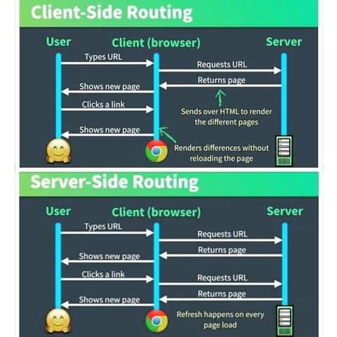 request for a new document.

Note : ***Formik*** ***library*** : to handle large forms